**FACULTY OF COMPUTING AND INFORMATION TECHNOLOGY**

AUTOMATIC DETECTION OF CANCER IN LYMPH NODES

CASE STUDY OF LAUSHRESS HOSPITAL/KINSHASA

BY

BUSOKA LUKENDO

BAIT/12/DC/J1335

**A GRADUATION PROJECT SUBMITTED TO THE FACULTYOF COMPUTING**

**AND INFORMATION TECHNOLOGY IN PARTIAL FULFILLMENT OF THE REQUIREMENTS FOR THE AWARD OF THE DEGREE OF BACHELOR OF INFORMATION TECHNLOGY OF ST. LAWRENCE UNIVERSITY**

May, 2015

**DECLARATION**

I, Busoka Lukendo, declare that the work presented in this research is original and my own effort to the best of my knowledge such a study has never been submitted for any diploma /degree in any University.

Signature…………………………… Date…………………………….

Busoka Lukendo

BAIT/12/DC/J1335

**APPROVAL**

This is to certify that this research Proposal of joseph Busoka Lukendo has been carried out under my supervision and now is submitted with my approval for award of Bachelors Degree of Information Technology in St. Lawrence University.

Signature……………………………..Date………………………………

MR. BAKER NYANZI

SUPERVISOR

St. Lawrence University

**DEDICATION**

This research is dedicated to my lovely family for their tireless effort, financial wise, moral and spiritual support. Special thanks go to my Dad Mr. Lukendobonga Waenge, my mother Mss. Nayenge Atonda, and all my brothers and sisters.

I also express my sincere appreciation to Mr. Baker Nyanzi… and all friends at St. Lawrence University for their moral and financial support towards my academics cycles at University.

**ACKNOWLEDGEMENT**

I extend my deep gratitude to all the people who helped me in all ways to get this report done, for had it not been with your help it would have been impossible for me to achieve this goal. I am very grateful to the Almighty God for having brought you all in my life, and for His continued provision and protection all through this journey.

First of all my deep thanks go to my supervisor Mr. Baker Nyanzi who through his tireless effort and continued support guided me in the right direction. I appreciate all the good advice he gave me during this period.

On a personal note I would like to specially thank my parents Rev. Lukendobonga Waenge Zabulon and Mss. Nayenge Atonda as well as my brothers and sisters for the moral support and constant encouragement given to me to ensure I finish this course. I am blessed to have you in my life and I am glad that you believed in me all the way. To all my friends‟ thanks for all the support rendered to me.

I am also grateful to the office of ICT department and to all the respondents who participated in the survey availing me with valuable comments and several important ideas, I say thank you so much.

My humble prayer is that God blesses each and every one of you and again thanks.

**ACRONYMES**

**4G**: Fourth Generation

**CRC: class** responsibilityCollaboration

**DRC: Democratic** Republic of the Congo

**MySQL**: My Structured Query Language

**NHA**: National Hospitals Authority

**OAREC**: Organization for Research and Education on Cancer

**OMG:** Object Management Group

**OO:** Object Oriented

**PHC**: Public Health Council

**PHP: Hypertext** Preprocessor

**RAD: Rapid** Application Development

**SDLC: System** Development Life Cycle

**SSL** : Secure Socket Layer

**UML: Unified** Modeling Language

**LIST OF FIGURES**

**Figure 1**: Cancer in South Africa

**Figure 2:** Shows a Structured Design Methodology

**Figure 3:** phased Methodology

**Figure 4:** Prototyping Methodology

**Figure 5:** Shows Throw-away Prototyping Methodology

**LIST OF TABLES**

**Table 1:** Shows the target groups and their targeted numbers.

**Table 2**: shows the system requirement.

**Table 3:**shows the patients table

**Table 4**:shows the tests table

**Table 5**:shows the topics table

**Table 6**:shows the comments table

**ABSTRACT**

The Automatic cancer detection in lymph nodes project has been in the building since Monday 7th of February 2015 and with thanks to God it will be completed on by the 1st of May 2015.

The project consist of a online system that will allow automatic cancer detection, based on a well-structured algorithm that analyses testing result and perform decision making against.

The design will be simple and concise to permit non educated users to access the system effortlessly, create an account and then perform testing and later get results.

When working on the project I have developed a great concept of thinking when it comes to online real time systems using technologies such as PHP or hypertext preprocessor which is a programming language that makes possible communication between the system and a database, in our case MySQL which is an open source database management system.

I am looking forward inserting SSL (secure socket layer) technology to keep secure data being processed by important transactions in the system. Right now we hope the system will help people who are using it to overcome some Problems they have been facing before such as not getting informed of our tests result in short time, having to move to get tested and to know results.

Today we bring you new technology and we will keep supporting the growth of technology in Africa and especially in DR Congo.

**TABLE OF CONTENT**

**Contents**

DECLARATION............................................................................................................. ii

APPROVAL........……………………………………………………………………….….iii

DEDICATION...................................................................................................................iv

ACKNOWLEDGEMENT ……………………………………………………….………..v

LIST OF TABLES................................................................................................………..vi

LIST OF FIGURES...........................................................................................................vii

**CHAPTER ONE................................................................................................................12**

1.1 Introduction …...............................................................................................................................12

1.2 Problem Statement….........................................................................................................................12

1.3 General Objective…………….........................................................................................................12

1.4 specific objectives.................................................................................................................................13

1.5 research question......................................................................................................... …………….14

1.6 Scope of the study……………..................................................................................................15

1.7 significance of the study……………………………...................................................................15

1.8definition of key concepts ………………………………………………………………………16

**CHAPTER II……….......................................................................................................... 4**

LITERATURE REVIEW……………................................................................................................. 4

2.1 The definition of the automatic cancer detection project…………………………………..15

2.2 Existing models……………………………………………………………………………17

2.3 south Africa framework…………………………………………………………………...19

2.4.System development life cycle……………………………………………………………..20

**CHAPTER III……………………………………………………………………………….29**

METHODOLOGY…………………………………………………………………………..29

3.0 Introduction .................................................................................................................................... 33

3.1 system design ..................................................................................................................................... 33

3.2 Prototyping Model ...................................................................................................................... 33

3.3 Systems development phases………………………………………………………………………34

3.3.1 Capture Requirements……………………………………………………………………………….34

3.3.2 Survey population……………………………………………………………………………………34

3.3.2.1 Target groups and targeted numbers ........................................................................... 34

3.3.3 Sampling design and size………………………………………………………………………….35

3.3.4 Sources of data………………………………………………………………………………………35

3.3.4 SOURCES OF DATA ................................................................................................................... 35

3.3.4.1Primary data....................................................................................................................... 35

3.3.4.2 Secondary data ........................................................................................................................35

3.4 Data management………………………………………………………………………………………36

3.5 Requirements Analysis……………………………………………………………………………..36

3.5.1 Functional requirement…………………………………………………………………………….36

3.5.2 Nonfunctional Requirements……………………………………………………………………..36

3.5.3 Minimum hardware and software system Requirements……………………………37

3.6 Developing the initial Prototype…………………………………………………………………….37

3.7 Review of the Prototype………………………………………………………………………………..38

3.8 Limitation of the study…………………………………………………………………………………..39

**CHAPTER IV ……………………………………………………………………………………………………40**

SYSTEMS ANALYSIS AND DESIGN ……………………………………………………………………… 40

4.0 Introductions………………………………………………………………………………………………….40

4.1 System Study………………………………………………………………………………………………….40

4.1.1 Existing system…………………………………………………………………………………………….40

5.1.2 Evaluation of the existing system………………………………………………………………….41

4.1.3 Weaknesses of the Existing system……………………………………………………………….41

4.2 System analysis and requirement specification ………………………………………………41

4.2.1 User Requirements………………………………………………………………………………………41

4.2.2 Functional Requirement……………………………………………………………………………….42

4.2.3Non functional requirements…………………………………………………………………………42

4.2.4 System Requirements…………………………………………………………………………………..43

4.3 SYSTEMS DESIGN……………………………………………………………………………………………43

4.3.1 Proposed System……………………………………………………………………………………….....43

4.3.2 Context diagram…………………………………………………………………………………………..44

4.3.3 Use case model description…………………………………………………………………………..44

4.3.4 Class diagram description……………………………………………………………………………..44

4.4. Performance Requirements……………………………………………………………………………47

4.4.1. Safety Requirements……………………………………………………………………………………..48

4.4.2 Security Requirements…………………………………………………………………………………..48

4.4.3 Physical design……………………………………………………………………………………………. 49

4.5.0 SYSTEM IMPLIMENTATION…………………………………………………………………………..50

4.5.1 INTRODUCTION…………………………………………………………………………………………….50

4.5.2 Login……………………………………………………………………………………………………………51

4.5.3 User Dashboard…………………………………………………………………………………………...52

4.5.4 Testing form…………………………………………………………………………………………………52

4.5.5 Testing results………………………………………………………………………………………………52

4.5.6 CONCLUSION………………………………………………………………………………………………..52

**CHAPTER V……………………………………………………………………………………………………….53**

CONCLUTIONS AND RECOMMENDATIONS…………………………………………………………….53

5.1 Introduction……………………………………………………………………………………………………53

5.2 Recommendation…………………………………………………………………………………………….54

5.3 Future work……………………………………………………………………………………………………55

5.4 Conclusion……………………………………………………………………………………………………...55

References……………………………………………………………………………………………………………55

APPENDIXES…………………………………………………………………………………………………………55

QUESTIONAIRE……………………………………………………………………………………………………..56

**CHAPTER ONE**

**1.0 Introduction**

This chapter contains definition of the Case Study, introduction to the Background of the study, statement of the problem, objectives, physical scope, significance of the study, and research questions.

**1.1 Background**

National programs are “necessary in Francophone countries and particularly in Congo where we have an outline plan which needs to be strengthened, «said pathologist Donatien Moukassa.

The cancer conference in Dolisie, southwestern Congo, from 18-21 December, agreed that cancer should be declared a public health disease on a par with malaria, tuberculosis and sickle cell disease.

“Fighting cancer requires substantial resources. Testing is expensive. In general, fewer than five patients in 10 have access to treatment," said Albert Mouelle Soné, Dean of the Faculty of Medicine and Pharmaceutical Sciences at the University of Douala, Cameroon.

"In Congo, a cancer patient, regardless of their social status, must pay at least 300,000 CFA francs (US$600) per month for treatment. It's huge," said oncologist Nkoua Mbon, noting that the average wage is $160.

Furthermore, African countries have so far largely failed to establish mechanisms to map cancer - there are insufficient records. "Until today there is no cancer registry in the DRC [a country of 60 million inhabitants]. We are fighting with the authorities to get it," said Jean-Marie Kasongo Mpolesha of the African Organization for Research and Education on Cancer (OAREC).

**1.2 Problem Statement**

Until now , most of medical entities in Congo still lack computerized systems that handle biometric activities, scanning, testing, storage and management of sensitive information that really matter for a hospital or any medical entity to prosper.

Therefore the automatic cancer detector will be design and developed to handle the cancer detection, data storage and management of all the hospitals in Kinshasa and later in Congo. The development task and accomplishment of this project will be handled by experienced project managers and developed by joseph Busoka a well reputed software developer. Since per now no computer system is in charge of automatic cancer detection and data management.

The accomplishment of this project will help a lot in cancer detection and prevention, as the system to be developed will be storing all susceptible and sensible data that can help in cancer fighting and will be free to everyone.

The fatality rate of people dying with cancer in Congo is 44%.

Since this rate is high we need to do something in the shortest amount of time to fight against this disease in order to make a better place for our kids.

**1.3 General Objective**

To develop an intelligent computer system to automatically detect cancer with a high security level for the data storage and management with user authentication and authorization.

In this project, the existing status on Congo Computerized Management systems is discussed to emphasize on the need for an integrated approach to cancer detection , symptoms studies and data management.

The best practices in the world are investigated, so that the detection approach to cancer will be the same or nearly the same compared to some of the best practices used in the world.

All these efforts are taken to avoid cancer to keep on spreading all over the world hence causing death, problems to the people in the world and in our case in the Democratic Republic of the Congo.

To finish, engineering improvements to computerized cancer detection in lymph nodes was considered in order to improve the safety of our environment and day to day life. Knowing that there is a problem, we as engineers we need to find optimal solutions in the very shortest amount of time.

**1.4 Specific objectives**

Objectives outline the actions that were taken to solve the automatic detection of cancer in lymph nodes problem that are stated in the previous section. The following are the objectives for this project:

a) To design a computer system that takes care of testing cancer and saving results in a database.

b) To implement distributed database in web based application to ease data management, storage, sharing.

c) To validate the sensitive data being received by the system processed and saved in the database.

d) To review at the end of the day the different user experience and perform some valuable solutions against.

**1.5 Research questions**

The study has various questions that it tried to bring out so that the stated problem can be solved. Below are some of the specific research questions behind this study.

* is there a system specialized to perform automatic cancer detection, data management?
* is the system automated or manual?
* are computerized systems favored by the country?
* how can the system be improved in terms of computer automation?

**1.6 Scope of the study**

The main focus of this project is to develop a web based intelligent system that will automatically detect cancer in lymph nodes, which is a system that store, manages, user interactions and information.

In this section, the scope was explained in terms of users, function and technologies.

Given that the system is an online system, the technologies and tools to be used will be purely for web based applications development such as:

1) Apache Web Server Version 2.2.4

2) Hypertext Preprocessor (PHP) Version 5.2.3 as server side scripting language

3) MySQL Database Version 5.0.45

4) PhpMyAdmin Database Manager Version 2.10.2

5) JavaScript as client side scripting language

**Geographical scope**

LAUSHRESS Hospital is located in the Democratic Republic of the Congo, precisely in Kinshasa the political and economic capital of the country.

The hospital facilities are located in the Ngaliema district.

**Time scope**

Knowing the development life cycle of a computer system the automated cancer detection system project is evaluated as a 3 months project.

The design and analysis will take 2 month as this is the core part.

The development and testing will then take the one month left.

**1.7 Significance of the study**

“Fighting cancer requires substantial resources. Testing is expensive. In general, fewer than five patients in 10 have access to treatment," said Albert Mouelle Soné, Dean of the Faculty of Medicine and Pharmaceutical Sciences at the University of Douala, Cameroon.

Kinshasa the capital city in Congo shows that the 44 % of fatality is caused by cancer.

This situation has been studied and the results show that people do not have access to the necessary treatments and ignore the essential information related to cancer.

We do believe that the project to automate cancer detection in lymph nodes will be of a great help for fighting cancer in the way that it will provide accurate information related to cancer for free to any user, the information will be provided by verified specialized doctors.

Most of the people die with cancer because they do not have money for getting the needed assistance, with the system to be built the user will be diagnosed in a very short time than usual.

The patient can easily interact with fellow users and also get advices from specialized doctors.

**1.8 Definitions of key concepts**

The project Automatic cancer detection in lymph nodes is essential for a better and safe environment.

Some key concepts of the underlined project are:

**Automation** (from automatic operation)

Automatic, as opposed to human, operation or control of a process, equipment or a system; or the techniques and equipment used to achieve this. Most often applied to computer (or at least electronic) control of a manufacturing process.

**Cancer**

Any type of malignant growth or tumour, caused by abnormal anduncontrolled cell division: it may spread through the lymphatic systemor blood stream to other parts of the body

**Detection**

The act or process of extracting information also, the act of discovering.

**Lymph nodes**

Any of the glandlike masses of tissue in the lymphatic vessels containing cells that become lymphocytes.

**CHAPTER II**

**LITERATURE REVIEW**

**2.1. The definition of the automatic cancer detection project**

The automatic cancer detection system project was established in 2013 on demand of the National Hospital Authority and the public health council referring to 5th amendment of the of public society charter Act, No. 13 and commenced with the preparation of a Business Plan and Strategy for its operations in January 2014.

Computerized systems are needed to capture specific data for calibration and validation purposes, to assist in base model development. This section details some of the information that may be required. The purpose of this document is to provide information on the establishment of the automation cancer detection system; its purpose and objectives; other general information about cancer; as well as to provide the names and contact detail of project managers.

The system operates at arm’s length from the Department and entrenches an effective partnership between provincial and local spheres of the capital city in the management of medial affaires. Recognizing the importance of the regulation of public health and development, safety and quality of life of all citizens, the purpose for which the project was established is:

* To enhance the overall quality data integrity, management and service provision;
* To strengthen the cooperation and coordination between the patients and medical staff.
* To maximize the effectiveness of provincial and local administration efforts, particularly in cancer fighting and health enforcement;
* To guide and sustain the expansion of private sector investment in medical entities.

The overriding aim of the idea is to overcome the recent disaster related to diseases like cancer functions across the city and local jurisdictions, and to bring a new professional coherence and improved morale into the entire system.

Data collection is an essential part of any information engineering, planning, or operational activity. Advanced data management and patient’s information services are supported by the collection of real-time traffic flow information on city segments especially during epidemical periods.

Advanced data management and storage information systems require real-time, online traffic data to effectively:

* Operate data entry, and data retrieval, responsive and traffic adaptive systems for hospitals and medical departments.
* Determine timing and values of testing activities.
* Regulate pricing.
* Detect and verify affected lymph nodes and other incidence.
* Develop a historical traffic flow database to support planning and evaluation.
* Provide patients’ and doctors’ information and updates data management data requirements are dependent on the application, whether it is to support real-time operational strategies, offline planning and administration, computation of measures of effectiveness, compilation of related statistics, verification of proper sensor operation, or research. The following sections discuss the traffic management functions supported by real-time and offline data acquisition and analysis and measures of effectiveness that require data collection to evaluate the performance of a testing management strategy.

The project has stipulated strict control measures over the functional units by requiring each functional unit to adhere to the business and financial plan, and each functional unit is required to enter into performance contracts with the Online System to ensure that they deliver the services for which they are responsible.

A wide span of management such as the project creates a flat organization, with few management levels between top and bottom. One of the most noticeable trends in recent years in modern management is toward flat organizational structures.

Organizations are moving toward these flat structures to cut the costs associated with levels of middle management, and to speed up decision making. The associated risk is that the remaining managers have greater responsibility and may be overtaxed.

The main function of upward communication is to supply information to upper levels on what is happening at lower levels. This type of communication includes progress reports, suggestions, explanations, and requests for aid and decisions, by C. William (1991)

**2.2 Existing models**

**Kinshasa (capital city)**

A closer look at Kinshasa the capital city in Congo shows that the 44 % of fatality is caused by cancer. The automatic cancer detection in lymph nodes system will help in fighting against cancer all over the country.

Cancer treatment level in 2007 is amongst the lower in the world with 16 patients registered per 1000 peoples.

The activities in the city have increased more than expected at the time of project appraisal. While the level projected for the year 2010 was 170 patients/ day, the actual level during 2012 as per the ministry of health count was 300 patients/ day; about 30% more than the projections Mrema (2009).

The collection of patients depends on patient’s fees and private sector contributions levels as well as traffic flows. In general terms, hospitals ownership levels are closely correlated to national GNI/per capital levels. This data corresponds with finding from the latest household from survey (house holder survey 2000/01). Hospital ownership at the house holder is insignificant; taking affordability into consideration 6% of Kinshasa householder and 2% of all other urban householders has a 1% patient in treatment.

Nevertheless, cancer patients in Kinshasa increased from 1% to 5% per household between 1991 and 2001. Other diseases in urban area and the capital city are low as well (1%). Rural infections are negligible (1%).

The project model was discussed, considering the existing situation, international best practice and financial requirements. It has taken many steps to prevent fraud within the system, and it is important that they abide by the regulations already put forward in the project Act. It was shown that not only is the proposed system feasible but also is essential if the current crisis is to be averted.

According to the proposed budget in 2011, the project is financially viable if the collection of money for patients and donations, which is the primary revenue of the department of health, is above 60%. However, the collection of fines at the moment is 15%, which would decrease the revenue to the department significantly.

A matter, which is of concern, is the length of time it has taken to reach the implementation phase. The sense of urgency, which was acknowledged at the outset, seems to have faded, and this needs to be rectified as soon as possible.

The Local Administrations of the country are taking steps to improve the citizen safety situation in the country. And have created the local public health community and doctors association. A key challenge has been the development of a national association safety policy and an action plan to harmonize the work of different stakeholders. Another challenge is to create a lead agency to harmonize and minimize duplication of work among the three existing key institutions (National Safety Council, Hospital management Directorate) and improve the efficiency citizen safety programs.

A draft public safety master plan has been developed and efforts are underway to create a new lead agency to coordinate health projects in Congo.

The stakeholders agreed to speed up the finalization of a national association safety master plan, lack of system controlling all the data, the acquisition of infrastructure; and the exploration of mobilizing resources for data safety. In addition, the National citizen Safety Council is strengthening the found action for the data safety strategic plan and policy by revising the system Code and developing a consolidated user and instructor training manual.

One of the recommendations made by the World report on data management injury prevention was for country to implement specific actions to prevent disaster, crashes, minimize injuries and their consequences, and evaluate the impact of these actions. Specific proposals to country with regard to protecting vulnerable data users included the incorporation of safety features into land-use and tests planning such as the provision of shorter and safer treatment, as well as safe, convenient, and affordable public health resources.

**2.3 South Africa framework**

One in six South African men and one in seven South African women will get cancer during their lives. Cancer is a great equalizer. it can strike anyone at any time.

A recent study published by medical journal Lancet predicts that South Africa could see an increase of 78% in the number of cancer cases by 2030.

From a global perspective, a 75% increase is expected, increasing the total incidence of all new cancer-cases from 12.7 million in 2008 to 22.2 million by 2030.

“Already cancer is one of the world’s leading causes of death and has the greatest economic impact in the form of premature death and disability. A recent study conducted by Livestrong and the American Cancer Society estimated the total global economic impact of premature death and disability resulting from cancer was $895 billion in 2008. The figure represents 1.5% of the world’s gross domestic product (GDP). The economic impact of a 75% global increase, and 78% local increase, could well be devastating,” says Professor Jacques Snyman, clinical advisor for Resolution Health Medical Scheme.

South Africa is ranked 50th on the World Cancer Research Fund’s list of countries with the highest cancer prevalence rates. Prostate cancer is the number one cancer diagnosed amongst South African men followed by lung, oesophagus, colon/rectum and bladder cancer. Amongst women, the most prevalent is breast cancer followed by cervical, uterus, colorectal and oesophageal cancer.

**Actual Statistics** 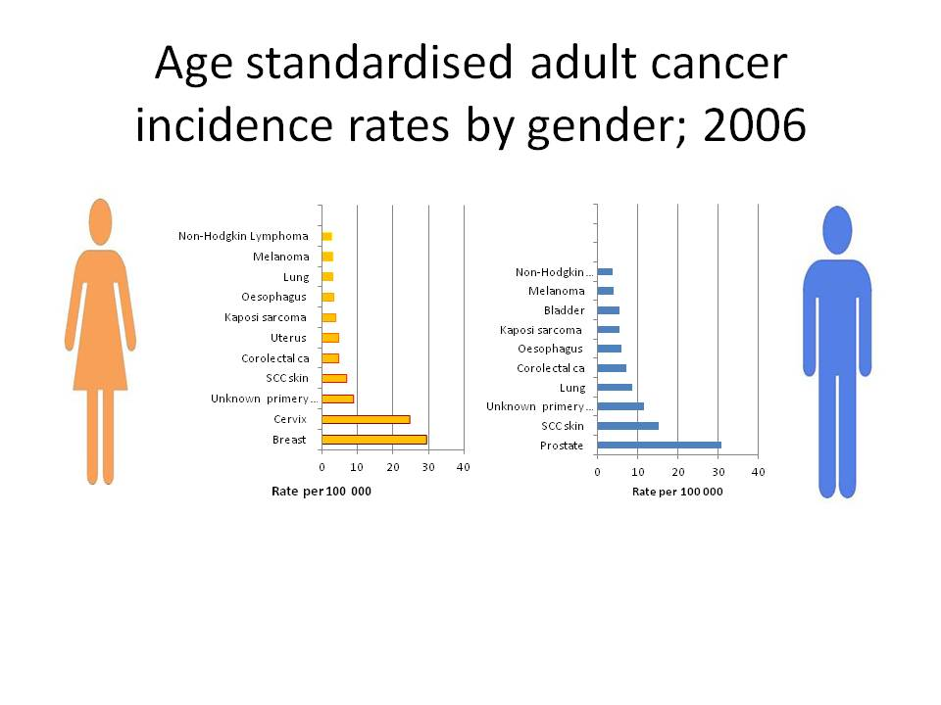*Figure 1. Cancer in South Africa*

**DR Congo case analysis**

Currently, there is no cancer registry in the Democratic Republic of the Congo. Professor Julien Ilunga and other clinicians and pathologists conducted a study on the incidence of cancers diagnosed in the various services, but there are no figures on the relative incidence of cancer in a defined population. For this reason, Dr Max Parkin and Dr Louise Ekobena-Ekobo carried out a consultant visit of evaluation at the invitation of Professor Ilunga to discuss the establishment of a cancer registry in Lubumbashi.

After this visit, a staff member (Papy Gael Mfunyi Muluma) from the Ligue Congolaise contre le Cancer attended the first AFCRN basic training course for French-speaking cancer registrars in sub-Saharan Africa, held in Abidjan, Côte d’Ivoire (11–29 August 2014). During the next review visit, progress in establishing a population-based registry for this city in the south of the Democratic Republic of the Congo will be evaluated.

There is no uniformity with respect to appointment of medical doctors, legislation, tariff structures of assurances, fines or collection levels.

Most authorities are operating medical duties, pathological tests and analytical functions at a loss.

Revenue is decreasing. Said the minister of finance (Matata mponyo).

Pockets of excellence are apparent, dependent on personalities and commitment.

Fraud and corruption seem evident.

In certain provinces the administrative function is at a standstill. 53 % of public health testing stations and 59 % of disease testing centers do not pass standards set by the National Department of medical affaire in terms of infrastructure and operational procedures of issuing patients and doctors medical needs.

Training, equipment, manpower levels and infrastructure are inadequate to perform the required functions.

**Attempts to solve the problem**

Many hospital, clinics and public health agencies in the world are struggling with similar problems to DRC; only the scale appears to change. Where excellence is experienced, many incremental steps have achieved this over a considerable period of time.

Clear strategies and continual focus on the desired end state is essential.

Media has indicated that the greatest advances in the world with respect to data for cancer frequency by country show that Denmark, France and Australia have the highest rate of cancer for men in the world as following:

Denmark: 338.1/1000. France: 324.6 /1000, Australia: 323.0/1000

The age-standardized rate was at least 350 per 100,000 in eight countries (France, Australia, Norway, Belgium, Martinique, Slovenia, Hungary and Denmark).

And for women as the following:

France: 385.3/1000 Australia: 373.9/1000 Norway: 368.7/1000

The age-standardized rate was at least 280 per 100,000 for Denmark, United States of America, Republic of Korea, The Netherlands and Belgium.

These countries have the highest annual cancer death rate compared to an annual world average.

The health department thus appointed a study team to visit these regions in June cc, in order to determine first hand, how cancer and other diseases, data management can be studied and treated. Many different departments were visited, from both federal and state (provincial) levels. The authorities were given an indication of the functional areas under investigation and meetings were arranged with them. International experts were impressed with the vision of the proposed measures and become so are enthusiastic about possible success. A full account of operational and legislative aspects per functional area was compiled as a result.

All the places visited have achieved marked reductions in cancer.

Despite decrease of medical infrastructures. These have been as a result of dedicated activities over considerable periods of time, linked to a clear coordinated and integrated strategy.

**2.4 System Development Life Cycle (SDLC) Methodologies**

According to Taylor (2004) SDLC (System Development Life Cycle), just as the name implies, is defined as the process (as a whole) of developing system or software to meet certain requirements. It covers many activities; starts from understanding why the system should be built, studying the project feasibility, analyzing problems, choosing the system design and architecture, implementing and testing it, up to delivering the system as product to the user.

SDLC is a process of gradual refinement, meaning that it is done through several development phases. Each phase continues and refines what’s done in the previous phase.

Commonly known development phases in SDLC are:

* Planning: It is the process of understanding why the system should be built and defining its requirements. It also includes feasibility study from several different perspectives, technical, economic, and organization feasibility aspects.
* Analysis: This phase includes activities such as problems identifying and analysis, and even predicting potential problems that may arise in the future regarding the system. The deliverables / products of this phase will drive how the system will be built and guide the developers’ works.
* Design: System analysis leads to design decision, which exactly determines how the system operates in terms of process, data, hardware, network infrastructures, user interface, and other important factors in the system environment.
* Implementation: This is probably the most resource-, cost-, and time-consuming phase of all. This is when the system is actually built, tested, and finally installed. It also includes activities such as user training and system maintenance. Some experts like to separate them into different phases Deployment and Maintenance. However the four phases are the most commonly known and accepted steps.

SDLC tries to achieve high quality system that meets or exceeds the requirements. Many methodologies have been developed and introduced in order to implement SDLC; some of them also try to improve other (previously) known methodology. Although each method follows certain different techniques and steps, they are all must go into the same development phases described above. There are many system development methods known today, but most of them basically are extended from three main methodologies which are Structured Design, RAD (Rapid Application Development), and Object-oriented Analysis and Design. Grutter (1997).

**Structured Design**

This method follows a step-by-step approach which moves logically from one phase to the next. The works done in each phase need to be approved by the project sponsor (this is usually the customer or the business analyst in an organization) before it can proceed to the next development phase. The Waterfall development methodology can be classified as this kind of methodology.

This rigor and inflexible manner make this methodology vulnerable to any business changes that happen while the development is still on the way, as it is extremely difficult to go backwards. This may require repeating the whole development process from the start and throw away all that’s been done, and in the worst case it could cause the change of project contract or agreement with the customer.

There are two approaches in developing system using this methodology, process-centered and data-centered approaches. Process-centered approach attempts to get the works done mainly from the perspective of the processes that exist in the operation of the system, which will likely result in system that constructed by process-oriented components. On the other hand, the data-centered approach concentrates on the data used by and involved in the system.

Structured design methodology has some advantages in that the rigor manner of this method forces the developers (analyst and his/her team) to well identify and understand system requirements long time before the implementation phase begins. At least it should have been approved by the sponsor before the developers start coding any programs.

The lack of ability to go backwards of the development phases makes this methodology unacceptable to business process changes as the project proceeds. Projects done using this methodology take a long time until users receive some deliverables because usually the system being built cannot be presented until it is completely done at the end of the implementation phase. Said Janssen (2010)



*Figure 2. Structured Design Methodology*

**RAD (Rapid Application Development)**

According to James E. Purcell (1999) RAD methodology enters to overcome the weaknesses of Structured Design method. RAD-based development tries to adjust the SDLC phases to have some part of the system (most likely the core function of the system) developed quickly to be delivered to the users. Certain types of RAD method also try to be adaptive to possible changes in the business process by concurrently perform all development phases at (roughly) the same time, like those manifested in the Prototyping RAD and Agile Development Methodology.

RAD methodology introduced the use of advance development tools like code generators and the visual fourth-generation (4G) programming languages such as Microsoft Visual Basic and Borland Delphi. The use of these tools speed up the development process and in some degree produces higher quality of codes. However as the system can be delivered quickly, users tend to change their expectations of what the system can do, thus the requirements tend to change and expand.

There are three categories of RAD:

**1. Phased Development**

This method breaks the requirements into a series of versions, based on which several versions of system will be built sequentially, being the most fundamental and important functions bundled in the first version. Sequentially here means that the next version development will begin only after the preceding version has been approved and implemented. Each version has its own Analysis-Design-Implementation phases (in a smaller scale compared to the overall system). All of these versions will later be tailored to form a complete system that meets the all functions just yet. And as the system will be built based on many sequential versions, it is very critical to identify important and fundamental functions to be included in the first version, an in-depth initial analysis of the system is needed.



*Figure3. Phased Development Methodology*

**2. Prototyping**

According to Janssen (2010) this methodology used usually when the business process is likely to be changed as the project proceeds or when the project sponsor has little idea of what system to be built. The Analysis, Design, and Implementation phases performed concurrently and on each cycle resulting in a system prototype that will be reviewed by the project sponsor. The cycle repeated continually based on the sponsor comments until the prototype successfully meets the requirements. The last prototype will then be called the system. Prototyping development needs only initial basic analysis and design, but as the result important system functions may not be recognized until somewhere in the middle of project timeline. Thus there is a possibility to alter the initial design decision and start all over again from the beginning. It can delivers system quickly to users, though it not exactly meets the requirements.



*Figure 4. Prototyping Methodology*

**3. Throw-away Prototyping**

Throw-away Prototyping is similar to the Prototyping method in that it also develops a prototype. But the throw-away prototype is rather presentational only, the prototype actually does nothing. It is intended to help users visualize the system being built. Based on the user’s comments, the next prototype continuously built until it can visualize the real working system. The next step would be implementing the real system. This throw-away prototype is also called dummy (mock-up) prototype. It is best if possible to do a thorough initial analysis before the developers start working on the first dummy prototype, as the dummy needs to contain enough details about the real system. This method doesn’t deliver incomplete systems within the project timeline like prototyping method, but in the end it delivers the complete system very quickly. It generally has shorter project timeline compared to other methods, because building dummies is considered easier and less time-consuming than building working prototypes.



*Figure 5. Throw-away Prototyping Methodology*

**Object-oriented Analysis and Design**

The Object-oriented methodology developed based on the lack of synergy between process-centered and data-centered approaches in SDLC. Decomposition of system into a set of process (process centric) or data (data centric) cannot be easily obtained, as both aspects are closely related one another. It is difficult to develop system by primarily focusing only to one aspect. As result, the system produced tends to be extendable only in one world. A process centric developed system can not be easily extended when there are changes in type of data in the system. This kind of problems also exists in the data centric developed system.

Methodology decomposes problems into objects. Objects are considered part of the system that contains both process and data, an object may do some activities/processes (mapped as object methods), an object may also have states (mapped as object attributes). This way, developers will focus on the entity in the system that actually does processes and carries data, rather than focus primarily only to one aspect. OO-based system development extensively uses a tool called UML (Unified Modeling Language), which is a set of standard in diagramming and modeling techniques invented by three champions, Grady Booch, Ivar Jacobson, and James Rumbaugh, when they worked together in Rational Software. In 1997 UML proposed to and accepted by the Object Management Group (OMG) as a standard diagramming notation in object-oriented system development.

An approach in system development must be:

Use-case Drive this means that use-case is the primary modeling tool to define system behavior. Use-cases describe how the users of the system interact with the system to perform activity. And as a use-case focuses only to one activity at a time, it is inherently simple.

Architecture Centric The term architecture centric gives a high level view of the system being developed. The software architecture chosen for the system should drive the specification, construction, and documentation of the system itself.

The system architecture must support three views of the system:

**Functional view:** describes system behavior from the perspective of users of the system. Use-case diagrams used to depict this functional view.

**Static view:** describes the structure of the system in terms of classes, methods, attributes, and relationships of objects in the system.

This view is depicted using CRC (Class Responsibility Collaboration) cards, as well using class and object diagrams.

**Dynamic view:** describes the internal system behavior in terms of object communications and change of states. UML tools used to depict this view are sequence diagrams, collaboration diagrams, and object state-charts.

Iterative and Incremental Iterative and Incremental paradigm means that each iteration of the system development must bring the system closer to the requirements. As SDLC is a gradual process, the UML diagrams used in OO-based development moves from a conceptual and abstract thing in the analysis and design phase to become more and more detail in the implementation phase. Said Alan (2008)

**CHAPTER THREE**

**METHODOLOGY**

**3.0 Introduction**

This chapter involves the different research methods that will be used in order to fulfill the objectives of the proposed system, such methods include; Fact Finding (Observation, Documenting, Interviews, Questionnaire) and Unified Modeling Languages for System design, database Languages for System implementation.

**3.1 System design**

System design contains Logical Design & Physical Designs; logical designing describes the structure & characteristics or features, like input, output, files, database & procedures. The physical design, which follows the logical design, actual software & a working system. There will be constraints like Hardware, Software, Cost, and Time & Interfaces.

Structured design is a data flow methodology. The graphical representation of data flow, communication & defining the modules & their relationship with each is known as Structure Chart. This method decomposes & modularizes the system so that the complexity & manageability will come down. Thus reducing the intuitive reasoning & promotes the maintainable provable systems.

This type of design follows top-down & hierarchy, which will have one single entry & single exit.

**3.2. Prototyping Model**

The prototyping model assumes that you do not have clear requirements at the beginning of the project. Often, customers have a vague idea of the requirements in the form of objectives that they want the system to address. With the prototyping model, you build a simplified version of the system and seek feedback from the parties who have a stake in the project. The next iteration incorporates the feedback and improves on the requirements specification.

The prototypes that are built during the iterations can be any of the following:

* A simple user interface without any actual data processing logic
* A few subsystems with functionality that is partially or completely implemented
* Existing components that demonstrate the functionality that will be incorporated into the system

**3.3 Systems development phases**

**3.3.1 Capture Requirements**

This step involved understanding the very basics product requirements especially in terms of user interface. The more intricate details of the internal design and external aspects like performance and security will be ignored at this stage.

To examine the nature of Traffic road management system, the study will use different methods of data collection. These included, an interview guide, observation and reviewing of existing data on the existing traffic road management system.

**3.3.2 Survey population**

1) Target groups and targeted numbers

In this research, the researcher targeted 10 officers of the road which included the 15 traffic policies, 12 administrators and 10 car owners. The total target numbers of respondents was 70 as shown below table according to the different target groups.

|  |  |  |
| --- | --- | --- |
| **Target Group** | **Questionnaires** | **Interviews** |
| Administrators | 12 | 13 |
| traffic Policy | 12 | 13 |
| Vehicle owner | 25 | 25 |
| Totals | 49 51 | |

*Table 1 .target groups and their targeted numbers*

**3.3.3 Sampling design and size**

A sample size of thirty beneficiaries is considered as a case study. This is because a case study provides much more detailed information than what would be available through other methods such as surveys and they also allowed one to present data collected from multiple methods. The researcher considers variations in terms of the different stake holders in question that are in terms of population and size.

**3.3.4 Sources of data**

The researcher will use both primary and secondary data.

**3.3.4.1 Primary data**

Primary data is original data which has not been published anywhere. It is obtained for the first time for a specific research problem. It will be got using different methods for example Interviews and observation. Primary data will be collected where secondary data will not be available.

**3.3.4.2 Secondary data**

Secondary data is that which already exist prepared or developed for some purpose rather than to solve the problem at hand. A researcher will get this information from Bank Slips, Payment Slips, and fine Payment forms.

The researcher also will review the existing documents, interviewed clients and monitored their behavior. Interviews will be conducted because they are effective tools for gaining insights into major problems as well as offering solutions or improvements. Interviews allow evaluators to gain firsthand knowledge and establish a relationship with the person being interviewed. Interviewers also obtain complete evidence that can further enhance data reliability. The successful conduct of interviews is highly dependent on establishing a good degree of trustworthiness with key informants.

**3.4 Data management**

**Qualitative Data Analysis**

Data will be analyzed during and after data collection. During data collection, the tentative themes and code categories will be confirmed and new ones formulated. After data collection, information of the same code categories will be confirmed and new ones formulated. After data collection, information of the same code categories will be assembled together and exemplary quotations will used to write a report and develop the system.

**3.5 Requirements Analysis**

**3.5.1 Functional requirement**

In the system development it was very important to put into consideration what is needed for the system to run; that is they specify specific behavior or functions of the system functional requirement was what is required to dictate he system functionality.

* Users are able to search the online database and update their records.
* The users are able to insert and read different document in the system after gaining the access.

The system administrator is able to; view, edit, delete both the patient’s details and studies details records even doctors’ data and generate reports from the system.

**3.5.2 Nonfunctional Requirements**

* Non-functional requirements are aimed providing inherent properties of the system to be built, other than system functionality. Non-functional requirements include scalability and performance, security, design constraints, logical database and availability.
* Security requirement – apart from login to the system, no much security considered while building the software.
* Availability- This system is a web application hence availability is paramount.
* Scalability and performance requirements – In most cases end-users are less interested in the scalability of a software product as long as the software technology components that comprise the product are available and they are satisfied with the overall performance. High-stres performance is not a requirement for this project and mysql database is not designed for applications under stress and heavy load.

**3.5.3 Minimum hardware and software system Requirements**

Minimum hardware and software requirements for this project are:

* Software Requirements: Web Browser such as Internet Explorer, Firefox (Mozilla), Google Chrome, Opera, Netscape, Safari etc.
* Operating system: Windows XP and above

Hardware requirements to run the above software

* Computer/Processor - Pentium III and above
* Memory - 1024 MB RAM

**3.6 Developing the initial Prototype**

The initial Prototype will be developed in this stage, where the very basic requirements will be showcased and user interfaces will be provided. These features may not exactly work in the same manner internally in the actual software developed and the workarounds will be used to give the same look and feel to the customer in the prototype developed.

When developing an initial prototype, hospital management and car public health comity are encouraged to participate and offer constructive comments and suggestions. Upon seeing the completed prototype, however, these departments may expect to see a working system almost immediately. It is important to manage user’s expectations, in order to:

* Ensure the user understands the purpose and scope of the prototype. Clarify the amount of work involved in full development.
* Ensure the patient understands that they should identify potential flaws in the prototype to ensure accuracy, even though it is not a complete system.
* Control the change process to ensure hospitals do not continually uncover new requirements or change requirements, to ensure the prototype converges quickly to an implementable form.
* Avoid being pressured into inadequate development of items that are ignored during the prototyping process, such as security, auditability, fallback, recovery, maintainability, performance, networking, or documentation.
* Ensure that rapid design of the prototype does not inappropriately replace structured design.

**3.7 Review of the Prototype**

The prototype developed then is presented to the user and the other important stakeholders in the project. The feedback will be collected in an organized manner and used for further enhancements in the product under development.

**Revise and enhance the Prototype**

The feedback and the review comments will be discussed during this stage and some negotiations happen with the customer based on factors like, time and budget constraints and technical feasibility of actual implementation. The changes accepted are again incorporated in the new Prototype developed and the cycle repeats until customer expectations are met.

**Throwaway/Rapid Prototyping**

A prototype will be developed as part of a throw-away approach but will not form part of the final solution. It will be likely to inform the final solution, but the prototype itself will not become part of the final solution.

Throw-away prototypes will be a useful way of exploring ideas, and gaining feedback from the client and/or end-user.

They will be used to answer questions. A question about a functional requirement will necessitate the rapid development of a prototype; perhaps using a particular tool, in order to answer that question.

Throwaway prototyping is also called as rapid or close ended prototyping; this is because this type of prototyping uses very little efforts with minimum requirement analysis to build a prototype. Once the actual requirements are understood, the prototype is discarded and the actual system is developed with a much clear understanding of user requirements.

Interface design, layout and interaction styles are another area which can be explored using throw-away prototypes. These are sometimes referred to as 'mock-ups' or 'click dummies' because they look realistic but contain little or no code to provide the functionality expected (e.g. clicking on an interface icon does not perform the function associated with the icon).

The speed at which throw-away prototypes can be generated and modified is a major reason for their use and why this method is sometimes referred to as 'rapid prototyping'.

They also provide a useful and meaningful way for a developer to walk the client and/or end-user through the system requirements as interpreted by the developer. Feedback from the client and/or end-user should aid in allowing misinterpretations or unnecessary complexities to be picked up and addressed at an early stage.

The speed of development and the potential to catch misinterpretations or missing features at an early stage can help to make the throw-away prototype a cost effective approach.

**3.8 Limitation of the study**

The study will be expensive as it involved a lot of spending such as internet researches, transport and report production costs. Some money will need to be collected from corporate members to cater for the expenses.

There will be a problem of getting full information from the high level administrators because of fear for the information to get accessed by the competitors who may use it negatively against the institution.

**CHAPTER FOUR**

**SYSTEMS ANALYSIS AND DESIGN**

**4.0 Introductions**

This chapter’s main objective is to develop and analyze models that are to be used in developing the application. The main issues then are to choose the design architecture, suitable user interfaces and program designs of the new system. In this chapter, the researcher focuses mainly on the structure and functionality of the new system. Database planning and design, interface design and query statements will be the main sub topics.

**4.1 System Study**

This section highlights at the analysis of the current system used by the medical entities to detect cancer in lymph nodes and manage the data records.

**4.1.1 Existing system**

The mechanism used in the country is basically manual and test details are kept in form of paper files for clinics and medical centers and stored in simple databases or spreadsheet programs like MS-access and MS-excel installed only in the administration offices.

The lack of computerized system that manages huge medical information of the country is has an impact to the working people who like most human beings have short falls in other words prone to mistakes in the way they deliver services. In fact mentioned that the lack of system is time wasting. Since the current system is manual in nature, tasks like analyses, result saving, data searching and data management (update, delete) can really be of time consuming hence reducing the productivity of the organization.

**5.1.2 Evaluation of the existing system**

The evaluation of the existing system included analyzing the current flaw in documents and the weaknesses involved in the existing system. The main aim of this evaluation was to enable the researcher get a summarized, structural perspective of the existing system and find out the short falls, which would be the basis for the researcher’s study.

**4.1.3 Weaknesses of the Existing system**

The procedures involved in addressing cancer test result records are manual hence taking a lot of time as far as serving the users is concerned. Records are kept in paper files which increase the bulkiness of available data as well as increasing need for storage space. This possesses a risk as far as limiting the privileges of which user should view, update, insert or delete records. These in the long run affect data integrity.

The records are vulnerable to threats such as access by authorized people.

All the above weaknesses zeroed down to the need of a computerized data analysis and management Management System that would help in cancer detection automatically in lymph nodes, data allocations and managing the country information and records.

**4.2 System analysis and requirement specification**

**4.2.1 User Requirements**

User and hospital managers working with medical management system in the country should have a good knowledge on working with computers or they should have training sessions so that they can get prepared to working with the new system.

The training program will be a separate organization by the CIT department. In addition Users in most cases are interest in the system that is; fast, simple, user-friendly, secure and less prone to errors, these have all been catered for in the designing phase of the system.

**4.2.2 Functional Requirement**

In the system development it was very important to put into consideration what is needed for the system to run; that is they specify behavior or functions of the system functional requirement that is required to dictate the system functionality.

* Users are able to search for different studies and test results.
* The users are able to insert and read different document in the system after gaining the access.
* The system administrator is able to; view, edit, delete the test results, analyses details and patients’ details, records and users’ data and also can generate reports from the system.

**4.2.3Non functional requirements**

* The system includes a secure login facility that allows only authorized users with valid usernames and passwords to gain access to it.
* Nonfunctional requirements were not concerned with the specific behavior of the system, the system can operate without them but they add more usability and a way to judge the operations.
* These describe the expected non-functionality of the system
* The system does not accept changing, deleting or viewing staff data if one is not an administrator.
* The system avoids wrong entry information thus ensures data integrity

|  |  |
| --- | --- |
| **4.2.4 System Requirements**  **REQUIREMENT** | **SPECIFICATION** |
| Software | * Windows 2000, windows XP, windows vista, Windows 7, Windows 8 and can also run on Linux and UNIX systems.  * PHP, MYSQL, Macromedia Dreamweaver Wamp Server should be installed for windows and UNIX respectively. |
| Hardware | * a recent model CPU such as Pentium or Celeron, say 2Ghz or faster  * 2GB RAM (1GB is OK Windows XP (Pro or Home)  *CDROM drive (DVD nice but no real need yet)  * DVI video adapter with at least 32MB RAM and supports 1280x1024 resolution, (VGA OK) - |

*Table 2: shows the system requirement*

**4.3 SYSTEMS DESIGN**

**4.3.1 Proposed System**

The researcher designed a traffic road Management System to ensure the traffic’s road records integrity, security and avoid Duplication and Plagiarism. The system is also designed to ensure ease of use hence increasing its efficiency and effectiveness.

To achieve the above, the following system design tools were used. These include a Conceptual diagram, use case diagram, and data modeling.

**4.3.2 Context diagram**

DATABASE

Request registration

ADMIN

PATIENT

Mange users and forum

Login feedback

Login attempt

Registration feedback

Perform testing

login

Get test results

MEDICAL CONTENT MANAGER

Login Feedback

Publish content and testint rules

*Figure 6:context diagram*

**4.3.3 Use case model description:**

A use case diagram its purpose is to present a graphical overview of the functionality provided by a system in terms of actors, their goals (represented as use cases), and any dependencies between those use cases.

The main purpose of a use case diagram is to show what system functions are performed for which actor. Roles of the actors in the system can be depicted.

Use Case diagrams are formally included in two modeling languages defined by the OMG: the Unified Modeling Language (UML) and the Systems Modeling Language (SysML).

Patient

Admin

Doctor Admin

*Figure 7: Use Case Diagram of the new system*

**4.3.4 Class diagram description:**

Class diagrams are widely used to describe the types of objects in a system and their relationships. Class diagrams model class structure and contents using design elements such as classes, packages and objects. Class diagrams describe three different perspectives when designing a system, conceptual, specification, and implementation. These perspectives become evident as the diagram is created and help solidify the design. This example is only meant as an introduction to the UML and class diagrams. Classes are composed of three things: a name, attributes, and operations. Mainly in the class diagram the names include about the traffic management generation ideas which explain about the way how user’s admin and different systems connect through this. Now the attributes include explanation which should be implemented in the names. this could be shown in the form of operations. this can easily explain how the general project is going to implement the various operations .the below diagram represents the class diagram which gives the following road traffic management system information.

M

1

-Username :

-Password:

+Add():void

+Update():void

+Delete():void

Firstname:

Lastname:

Email :

Phone :

+control users():void

+check testing():void

+Handle testing rules():void

**Doctor Admin**

**Admin**

1

M

**Patient User**

-Firstname:

-Lastname:

-Email :

-Phone :

-Address:

Perform testing():void

Check results():void

Search():void

M

M

*Figure 8:**Sequence diagram description:*

A Sequence diagram in Unified Modeling Language (UML) is a kind of interaction diagram that shows how processes operate with one another and in what order. It is a construct of a Message Sequence Chart.

Sequence diagrams are sometimes called event diagrams, event scenarios, and timing diagrams.

Sequence diagram:

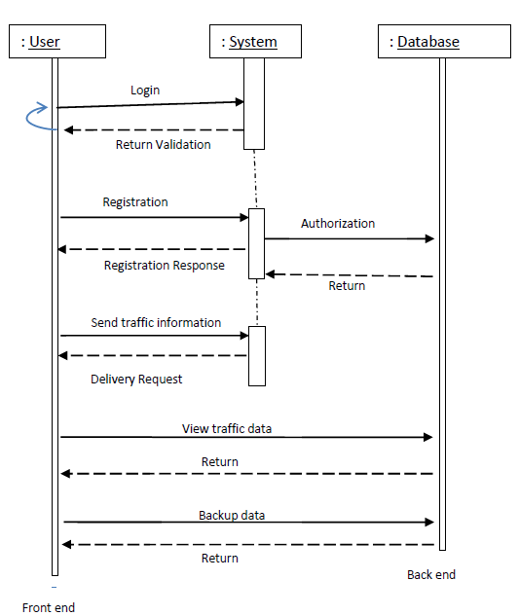

*Figure 9:sequence diagram*

**4.4. Performance Requirements:**

System can withstand even though many of customers request the desired service. Access is given to any users

**4.4.1. Safety Requirements:**

By incorporating a robust and proven DB2 UDB into the system, reliable performance and integrity of data is ensured. There must be a power backup for server system. Since the product is of 24x7 availability there should be power backup for server which provides the information. Every day the data should be backup even when the operation of a user is not successful i.e., while performing the operation power failure occurs then data should be backup.

**4.4.2 Security Requirements:**

Sensitive data is protected from unwanted access by user’s appropriate technology and implementing strict user-access criteria. Facility of unique user number and Password in such a

Way that unauthorized user cannot log in. Operational rights for each user/terminal can be defined. Thus, a user can have access to specific terminals and specific options only.

**4.4.3 Physical design:**

**DATA DICTIONARY**

1. Patients Tables :

|  |  |  |
| --- | --- | --- |
| **Attribute Name** | **Attribute Type** | **Attribute Size** |
| FirstName | String | 30 |
| LastName | String | 30 |
| Email | String | 50 |
| Phone | String | 15 |
| Password | String | 50 |

*Table 3:shows patients table*

2.tests

|  |  |  |
| --- | --- | --- |
| **Attribute Name** | **Attribute Type** | **Attribute Size** |
| Email | String | 30 |
| Result | String | 30 |
| Test_date | Date |  |
| Descriptions | String | 255 |

*Table 4 .shows tests table*

3.topics

|  |  |  |
| --- | --- | --- |
| **Attribute Name** | **Attribute Type** | **Attribute Size** |
| Topic | String | 30 |
| content | String | 30 |
| Topic_date | Date | 50 |

*Table 5 .shows topics table*

4.comments

|  |  |  |
| --- | --- | --- |
| **Attribute Name** | **Attribute Type** | **Attribute Size** |
| comment | String | 30 |
| owner | String | 30 |
| Comment_date | Date |  |

*Table 6 .shows comments table*

**4.5.0 SYSTEM IMPLIMENTATION**

**4.5.1 INTRODUCTION**

This chapter looks at the procedure used to physically realize the user interfaces and the database design converted into the physical database. HTML, JavaScript, PHP and MYSQL are the software’s that were used to implement the system.

**4.5.2 Login**

Logging into the system is primarily for all the patients users, the system has been designed to directing users to the different access levels automatically depending on the user’s access level. Therefore, the user only inputs his username and password if they are valid then the system automatically decides his access level.

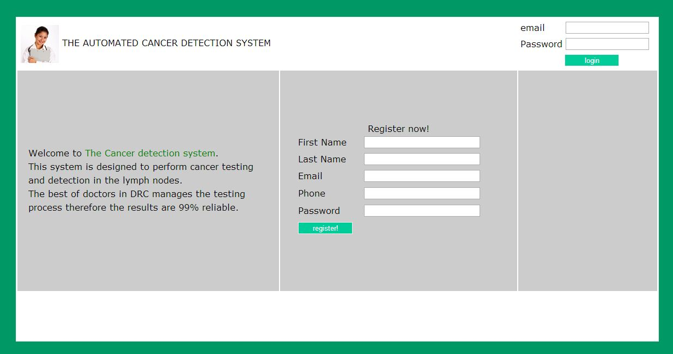

*Figure 9 show the system login screen*

This is the page where users have to provide the username and password so as to gain access to the system.

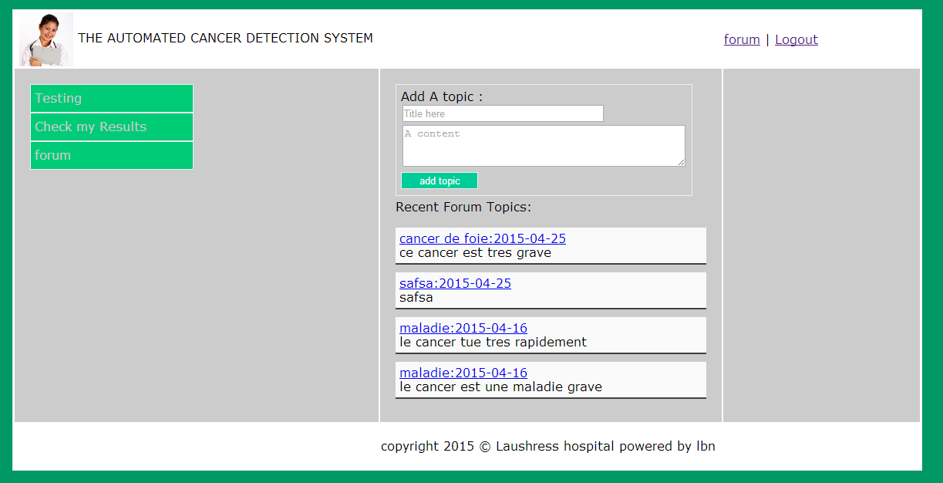

*Figure 10 shows the user dashboard*

This is the user dashboard containing the links to the main objectives of the system: Testing and result checking pages. This page contains also the patient’s forum.

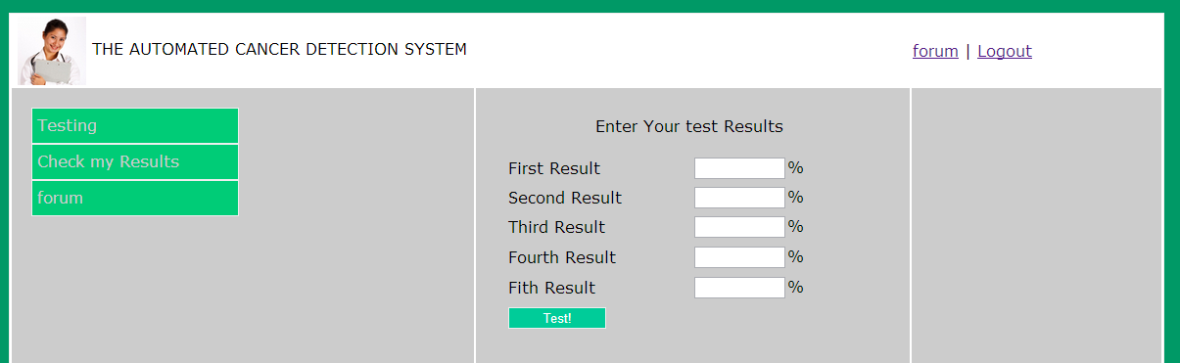

*Figure 10: shows cancer testing form*

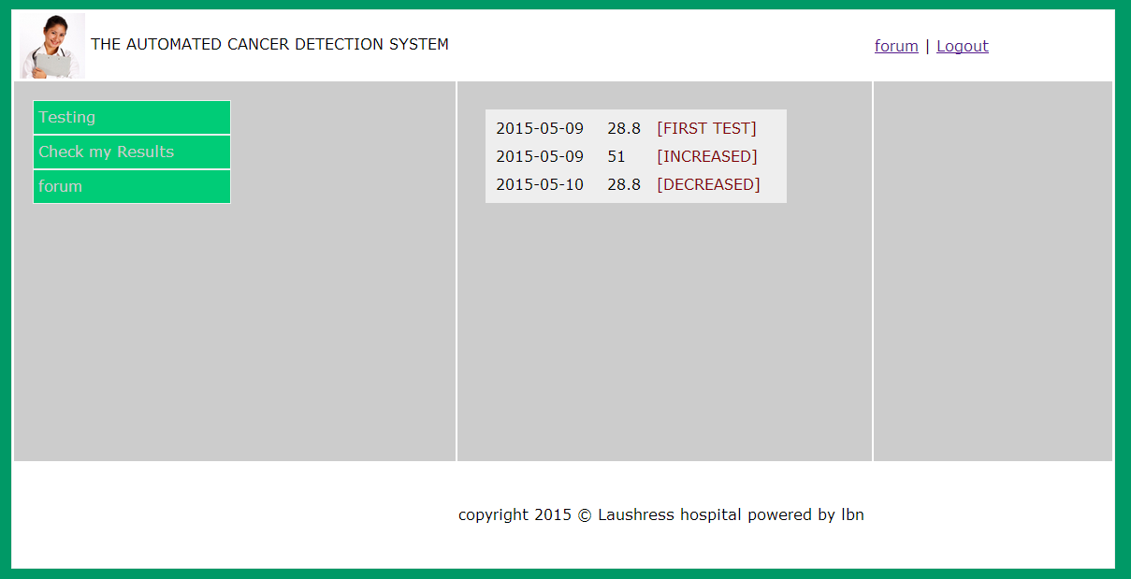

*Figure 11:show cancer results after testing*

**5.5 CONCLUSION**

This chapter discussed the implementation and testing phases of the system development, system operations and functionality of the new system to help computerize the Cancer testing task at laushress Hospital. This leads to the last chapter of the study which is conclusions and recommendations of the study.

**CHAPTER FIVE**

**CONCLUTIONS AND RECOMMENDATIONS**

**5.1 Introduction**

In this era of new technologies, computerization has led to more efficiency in the field of data management. Most of the organizations and businesses are trying to catch up with the new technology by having their records computerized. Computerization of organizational records has replaced the traditional manual file system that had many loopholes and can fit the standards of modernization.

Laushress Hospital being an organization that has future plans of expanding and providing more services to the public, having its records automated would make it do its planning easily and have clear data to use in its academic excellence and progress.

**5.2 Recommendation**

Having done and completed this study, I have tested the system and can now put forward the following recommendations.

I recommend that Laushress Hospital get computers for all its managers and Heads of departments offices and connect them on the intranet so that all the information can be shared. This wills easy the processing of the country’s traffic road information.

The IT Department should ensure that there is some training carried out for all users before starting to use the application. This will make the use of the application easy to the staff.

More, the system administrator should make sure they have some external storage devices to back up the data from the application in case of system failure so that they can use it for reference. Such devices can include external hard discs and CDs.

**5.3 Future work**

There has been short time given to develop the application so some required functionalities are not included, given more time other functionalities will be added.

There is still room for application expansion and this can be done in future to expand the system, for instance that the application can be able to synchronize data from the intranet to the internet automatically, allow doctors to communicate to each other via internal messaging.

Lastly this system can be nationalized so that all the entire country hospital and public health entities could benefit from its reliable services.

**5.4 Conclusion**

During this study, the researcher has been able to see how computerization of country’s hospitals and information in the country can benefit its excellence. The developed application is able to do the following tasks.

* Capture information using forms that have been created in the database and be viewed as graphical user interfaces. This makes the system user friendly.
* Retrieve data from the database this is done by use of view records’ Full details button.
* Detect errors in the system for example when a user is not registered they are not allowed to log onto the system or Submitting empty data spaces in the system.

**References**

1. Berlack, H.R. (2005). Software configuration management. New York: Wiley.

2. Boehm, B. & In, H. (2006). Identifying Quality-Requirement Conflicts. IEEE Software, 13(2): 25-35.

3. Chen, P.P. (2006). The Entity-Relationship Model: Towards a Unified View of Data. ACM Transactions on Database Systems. 1(1): 9-36.

4. Chung, L., Gross, D., & Yu, E. (2009). Architectural Design to Meet Stakeholder Requirements. Software Architecture. Patrick Donohue, ed. Kluwer Academic Publishers. pp. 545-564.

5. Chung, L., Nixon, B., & Yu, E. (2007). Dealing with Change: An Approach Using Non-Functional Requirements. Requirement Engineering. Springer-Verlag, 1(4): 238-260.

6. Chung, L., Nixon, B.A., Yu, E. & Mylopoulos, J. (2000). Non-Functional Requirements in Software Engineering. Kluwer Academic Publishing.

7. Coad, P., & Yourdon, E. (2010) Object-Oriented Analysis. Englewood Cliffs, NJ.:Yourdon Press.

8. Software Development Life Cycle (SDLC), Power Point, – Powered by Google Docs

9.W. Pohs, G. Pinder, C. Dougherty, and M. White. “The lotus knowledge discovery system: Tools and experiences,” IBM Systems Journal, Vol. 40, 2001, pp. 956-966.

**APPENDIXES**

APPENDIX A (Time Table for the Supervision Events)

Table 2: Shows the Time Table for the Supervision Events

|  |  |  |  |
| --- | --- | --- | --- |
| **No** | **Activity** | **March 2014** | **May 2nd -2014** |
| 1 | 1st Proposal Draft |  |  |
| 2 | 2nd Proposal Draft |  |  |

APPENDIX B (Gantt chart)

Table 3: Shows Gantt chart.

|  |  |  |  |  |  |
| --- | --- | --- | --- | --- | --- |
| No | Activity | Dec.10th-15th 2014 | Jan.10th 2015 | Feb.10th2015 | May.10th 2015 |
| 1 | |  | | --- | | Feasibility Study | |  |  |  |  |
| 2 | |  | | --- | | Data collection | |  |  |  |  |
| 3 | |  | | --- | | Coding | |  |  |  |  |

APPENDIX C (Budget Estimate that were used)

|  |  |  |
| --- | --- | --- |
| ITEM | QUALITY | COAST |
| Rim of paper  Transport  Software  CDs | Rims of paper  To and from  2 soft wares  3 CDs | 30,000/=  20,000/=  40,000/=  30,000/= |

**A) Questionnaires**

Dear sir/madam:

Subject : RESEARCH QUESTION

You have being identified as one of the most suitable person to provide the necessary information for the purpose of completing this research

INTRODUCTION:

Am Busoka Lukendo Joseph 3rd year client at St. Lawrence University carrying a research about Laushress Hospital computerized system, one of the requirement to complete the degree of Information Technology (IT) is to undergo the research and implement an information system which can be an applicable.

The information to be provided in this questionnaire is private and confidential. It will not be shared and given out to any other third party or whatever.

**Questionnaire one**

Staff Questionnaire.

This will capture client’s information and the requirements for admission/registration.

1. Staff information

Name’s……………………………………………………………………………………………………………………………………………………………………………………………………

Gender (tick where applicable)

F

M

Date of birth ………………………………………..

Religion ……………………………………………….

Address………………………………………………….

2. What are the requirements for one to be registered?

(List them).

…………………………………………………………………………………………………………………………………………………………………………………………………………

3. What registration procedure do you use?

……………………………………………………………………………………………………………………………………………………………………………………………………………………………………………………

4).how long does the process take?

……………………………………………………………………………………………………………………………………………………………………………………………………………………………………………………

5).According to your opinion is the system effective?

Give reasons

……………………………………………………………………………………………………………………………………………………………………………………………………………………………………………………

6).What are your views to put the system in place?

…………………………………………………………………………………………………………………………………………………………………………………………………………

**Questionnaire two**

Manager’s questionnaire

1.what systems do you use to store people data and information?

……………………………………………………………………………………………………………………………………………………………………………………………………………………………………………………

2. how do you retrieve peoples data?

………………………………………………………………………………………………………………………………………………………………………………………

**Questionnaire Three**

Client questionnaire

Is there a systems the staff use to capture your data and information?

………………………………………………………………………………………………………………

Are you contended with the services? ………………………………………………………………………………………………………………………………………………………………………………………………………………

Thank You for Your Cooperation.